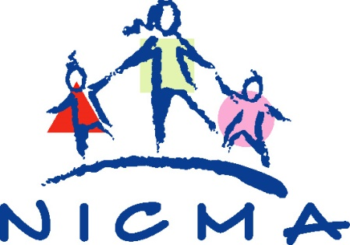

To all childminders- Guidance from the Health and Social Care Board

Dear Childminder,

From 1st August 2020, there are changes to the Department of Health’s Guidance for childminders.
From that date there is no restriction to the number of households that childminders can care for. The maximum number of children to be cared for at any one time must be no more than those detailed on the certificate of registration from the pre COVID19 period and includes children of the childminder’s own family.

Childminders must continue to follow public health advice and the Department of Health’s Guidance for childminders during COVID19 particularly in relation to infection prevention and control. .

The Department of Health Minimum Standards for Childminding and Daycare will also apply in full.

Childminders that have not already opened must contact the Trust Early Years Team to reactivate their registration to have this completed, and be able to give assurance that they have read the Guidance and can provide care as safely as possible. A risk assessment must be carried out before reopening, giving consideration to the DoH guidance.

Updated Guidance for Childminders will be available on the familysupportni website soon so please continue to check

Thanks you for your support

HSCB

